Name: ________________________________________ Arr: _________

Chapter 15 Written Problems Worksheet

**Use this sheet to record your answers to the following Chapter 15 Challenge Problems.**

**+**

**15-4.** Examine this **LED** schematic and state which way the current will flow. Left-to-right or right-to-left?

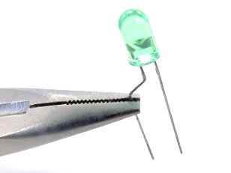**15-5.** Examine the image of a **LED** on the right and state which way the current will flow. Left-to-right or right-to-left?

**15-6.** Circle the image(s) below that show the proper way to connect an LED to some voltage source. That is, in which image(s) will the LED illuminate when power is supplied? The black wire inserted into the breadboard on the left rear is the ground wire, and the power wire is the red wire on the right rear. Assume the resistor value is chosen correctly.

**Figure A.**

**Figure B.**

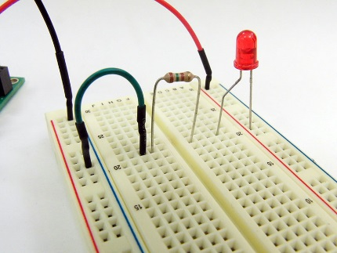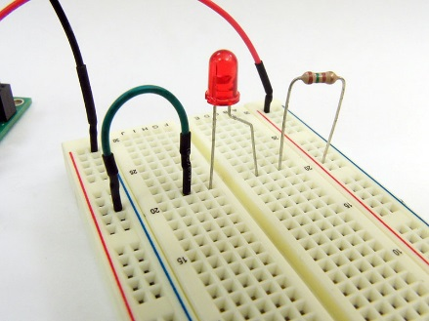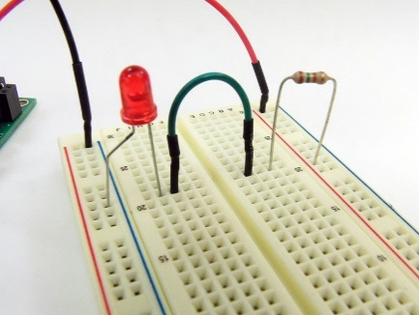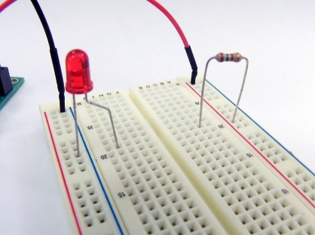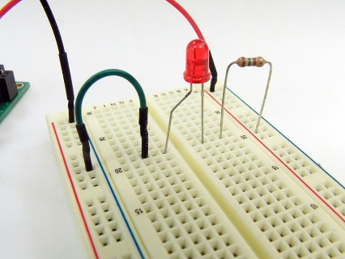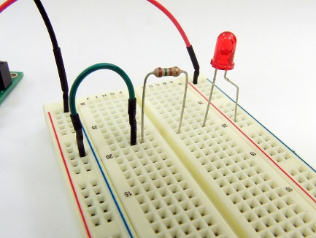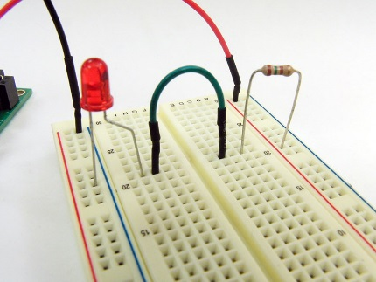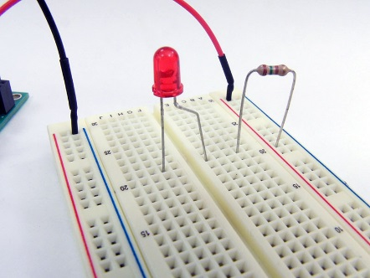

**Figure C.**

**Figure D.**

**Figure E.**

**Figure F.**

**Figure G.**

**Figure H.**

**15-18.** The wall transformer shown in Figure 15.40 below will be used to power the LED-resistor circuit shown in Figure 15.41. Examine the circuit, paying close attention to the jumper wires from the power and ground buses, as well as the orientation of the LED. (Its bent lead is the longer, positive lead.) The barrel plug conductors from the wall transformer, (**A**) and (**B**), can be connected to the jumper wires from the breadboard, (**C**) and (**D**). Which should be connected to which?

**Figure 15.40.** The barrel plug conductors from this wall transformer are labeled (**A**) and (**B**).

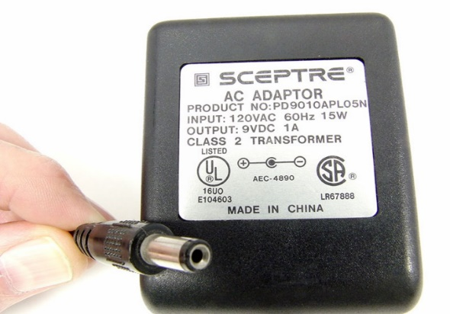

**(A)**

**(B)**

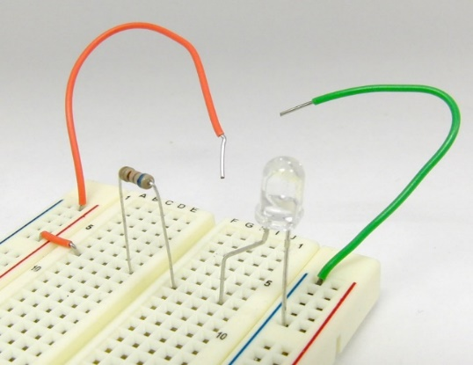

**(D)**

**(C)**

**Figure 15.41.** Jumper wires from this breadboard are labeled (**C**) and (**D**).

1. _______ (C or D)
2. _______ (C or D)

Turn in this sheet to be graded.